*Florida International University*

*School of Computing and Information Sciences*

Software Engineering Focus

Feature Document

User Story ID #665

**Name:** Mario Fidalgo

**Team Member(s):** Kyle Ryan

**Project:** Mobile Judge 9.0

**Product Owner(s)**: Masoud Sadjadi

**Mentor(s)**: Masoud Sadjadi

**Instructor**: Masoud Sadjadi

**User Story Name: Add a Judges view for each student**

**Description**

As an admin, I would like to be able to select a desired student and view all the judges who graded that student.

**Acceptance Criteria**

* I should be able to select all or select only the ones I desire.
* The buttons should flow with the design of the rest of the system.
* I should be able to view the grades given by each judge and for all judges.
* I should be able to change the status to accepted/rejected/pending.

**Use Case**

* Name: View Judges for a student
* Actor: Admin
* Preconditions: User must be logged in as an admin and in the grade view.
* Description <Flow of events>:

1. User clicks on a student

2. System displays a view of all the judges for that student

**Use Case Diagram**

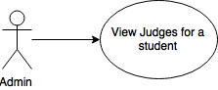

**Sequence Diagram**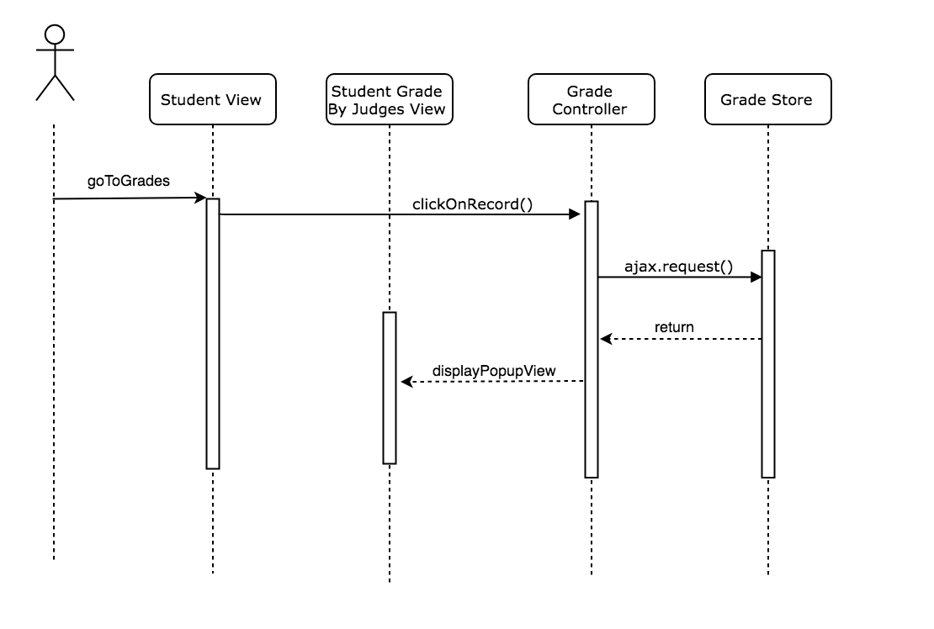

**Class Diagram**

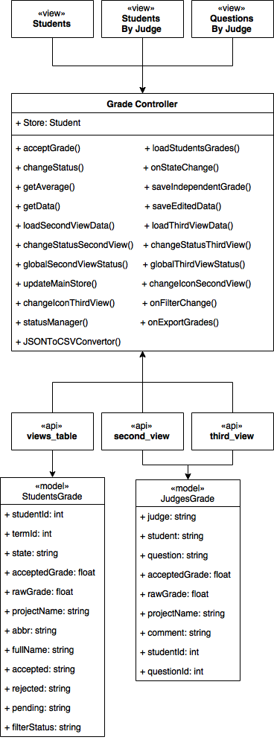

**Unit Test & Integration Test**

|  |
| --- |
| **Test case ID**: MJ-665-01  **Description/Summary of Test**: View judges who graded a student  **Precondition**:   * Admin is currently logged into Mobile Judge account * Currently on the grade side tab * Viewing the student gridview * Select a student   **Expected Results:** Popup appears with list of judges who graded the selected student  **Actual Result:** Popup appears with list of judges who graded the selected student  **Status (Fail/Pass):** Pass |